# Install OpenCV 3 and Dlib on Windows (Python Only)

Please see more detail from here: <https://www.learnopencv.com/install-opencv-3-and-dlib-on-windows-python-only/>

## Download and install node.js

* Download node.js: <https://nodejs.org/en/download/>

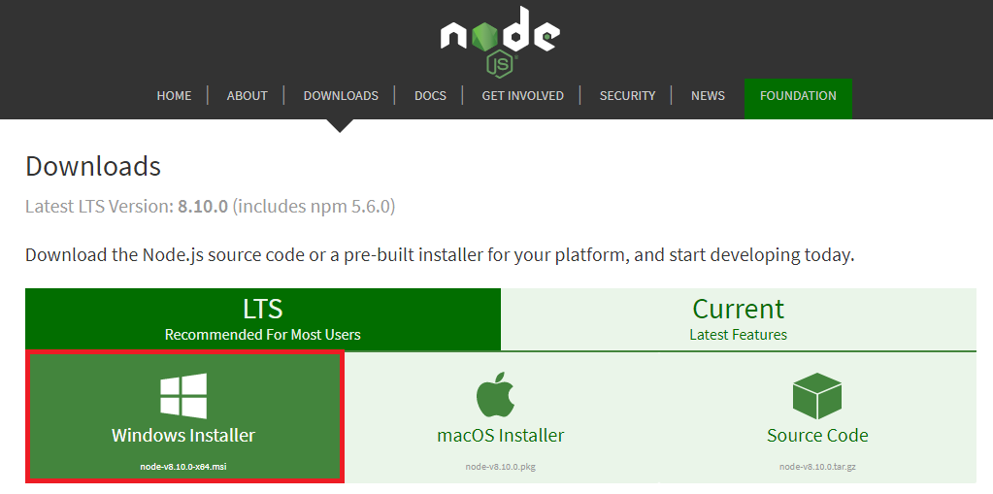

* Select **Windows Installer** wait until download completed.
* Start install by double click on .msi file

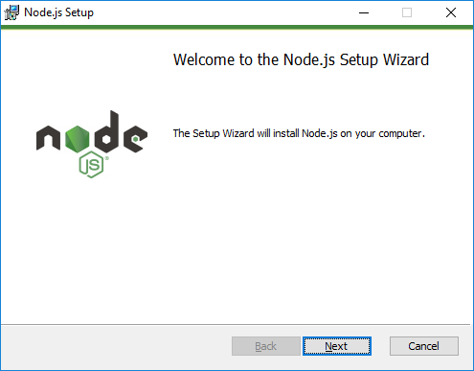

* Click **Next** to continue

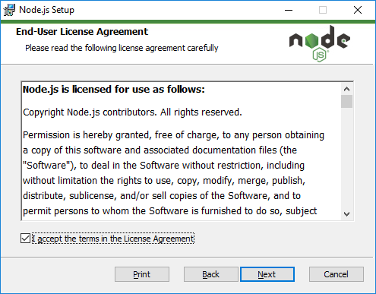

* Click **‘I accept the terms in the License Agreement’** then click **Next**

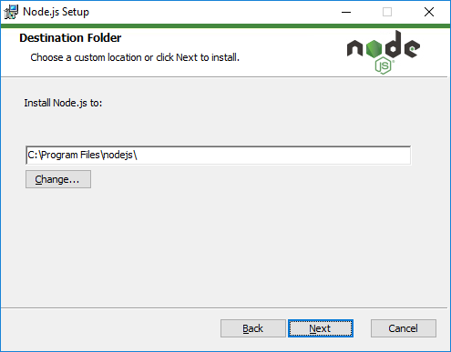

* Change folder to install Node.js or keep default then click **Next**

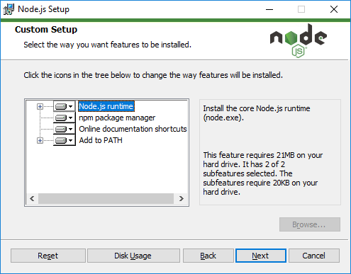

* Keep default setting then click **Next**

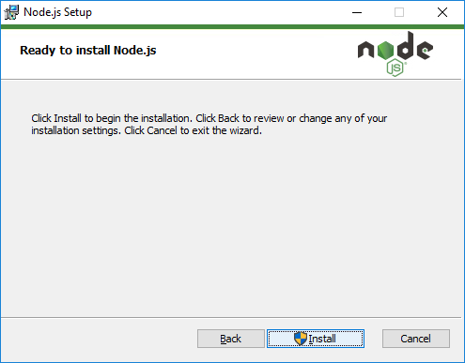

* Click **Install** to continue

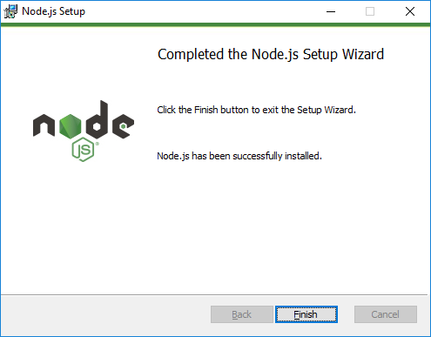

* Click **Finish** to complete install.

## Download and install python 3

* Download python: <https://www.python.org/downloads/>

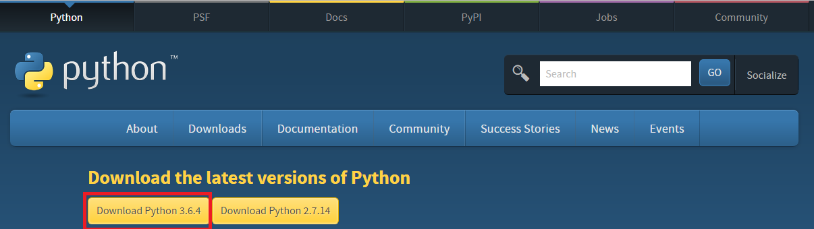

* Select **Download Python 3.x.x** to download.
* Click on install file downloaded from pervious step

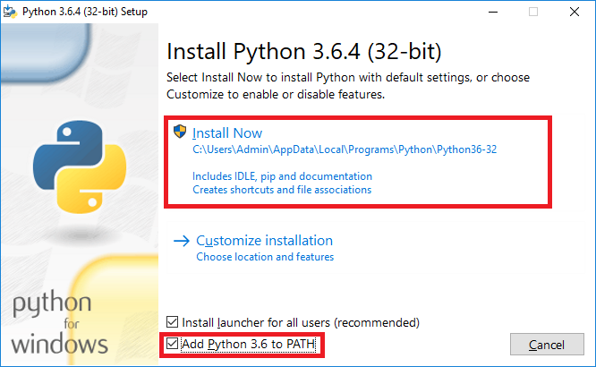

* Check on **Add Python 3.6 to PATH** then click **Install Now**

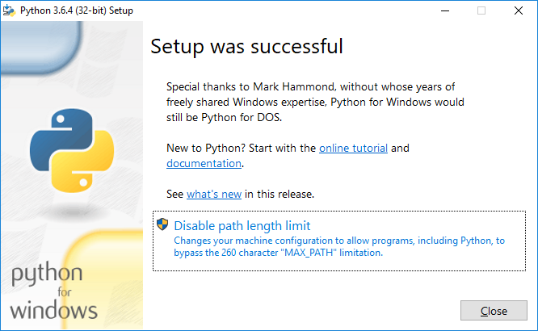

* Click **Disable path length limit** then click **Close** to complete install.
* Open command then enter python to verify install correctly or not

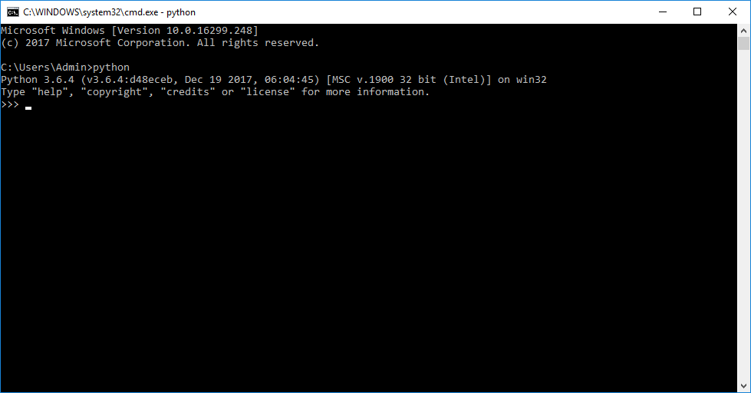

## Download and install Microsoft Build Tools 2015

* Navigate to https://www.microsoft.com/en-us/download/confirmation.aspx?id=48159
* Open file downloaded from previous step to install

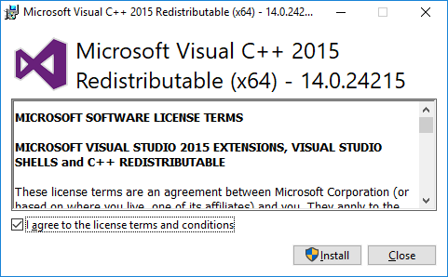

* Click Install

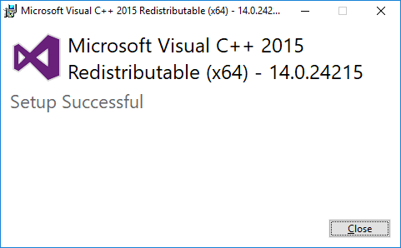

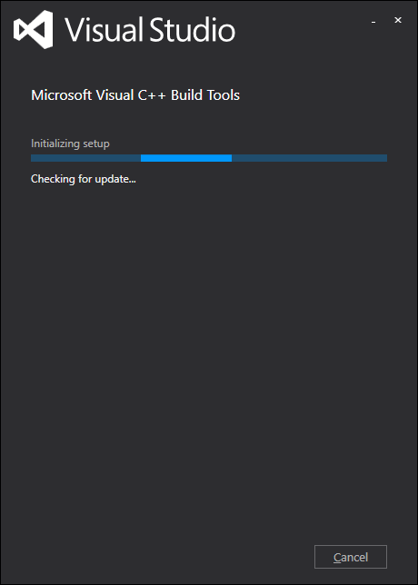

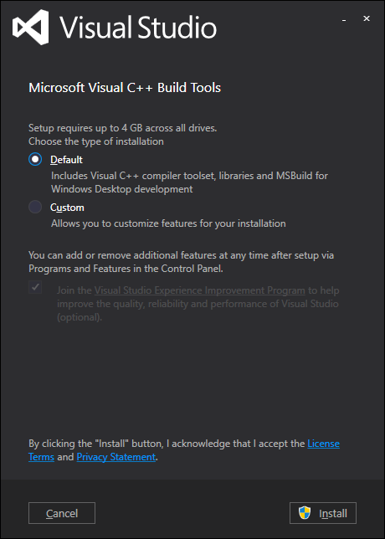

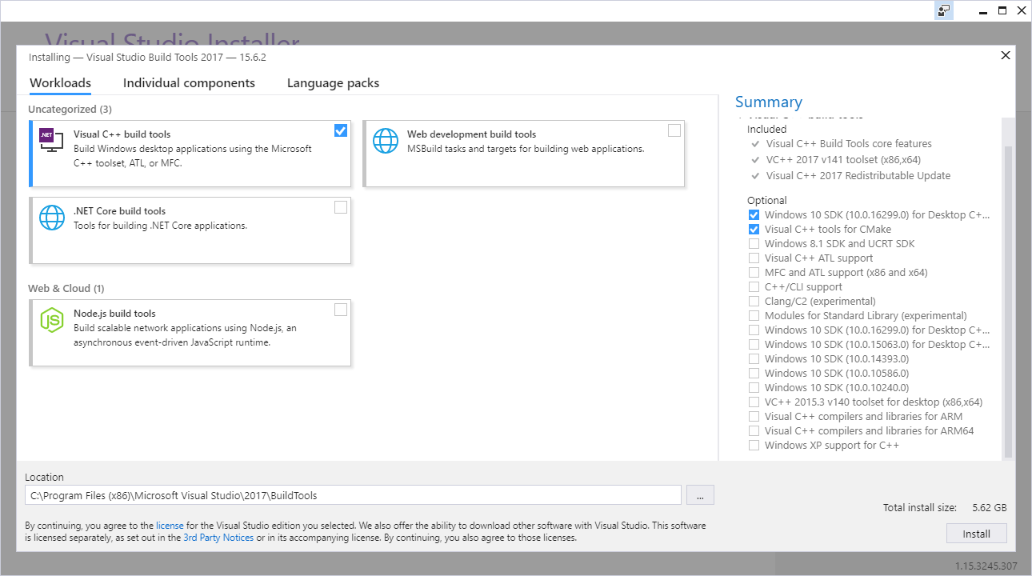

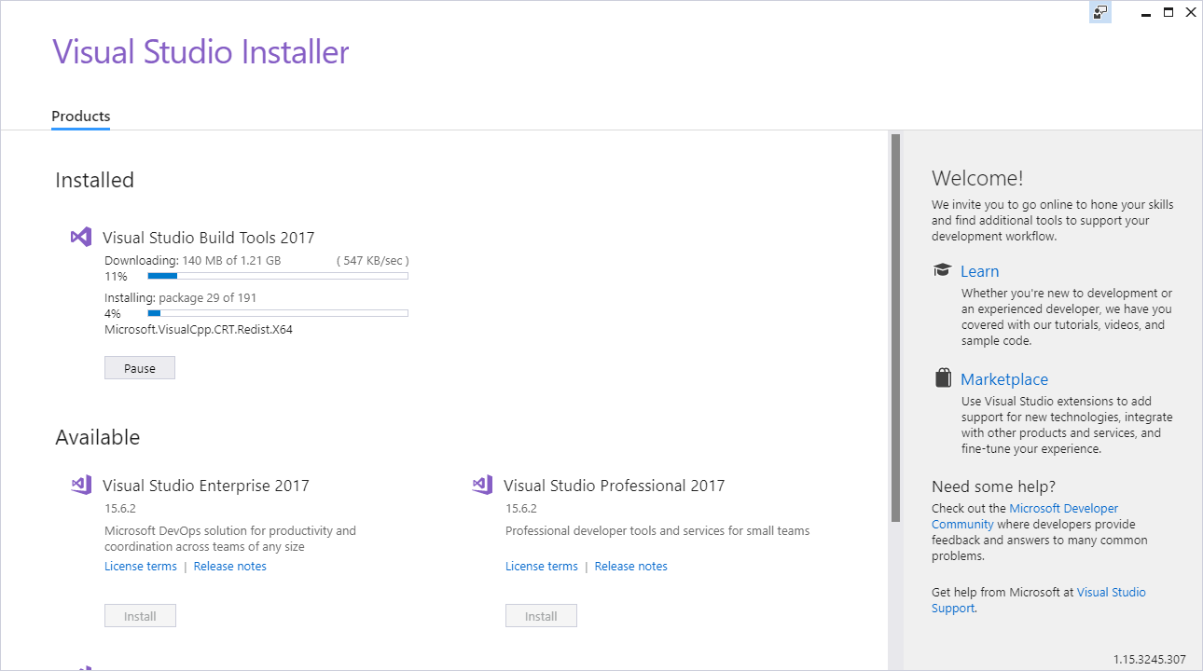

## Download and install Cmake

* Download Cmake from here: <https://cmake.org/download/>

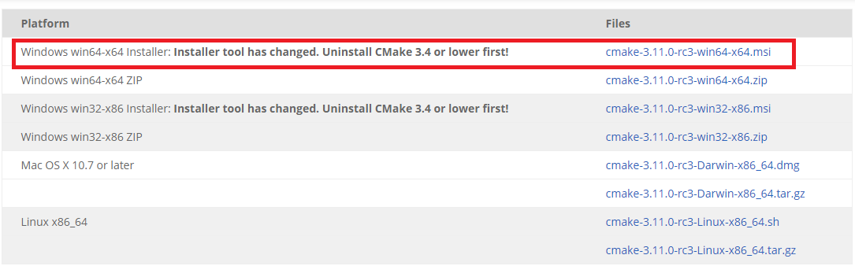

* Choose your version, in my case I choose cmake for windows 64 bit
* Open install file downloaded from previous step

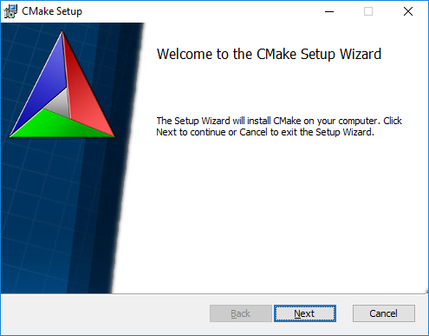

* Click Next to continue

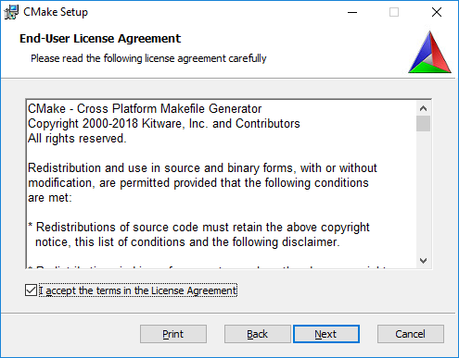

* Click ‘I accept the terms in the License Agreement’ then click Next

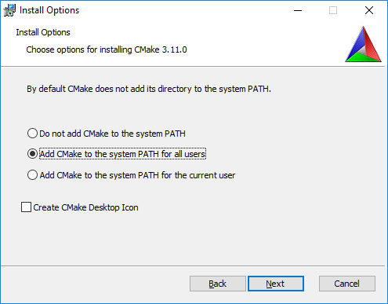

* Choose ‘Add CMake to the system PATH for all users’ then click Next

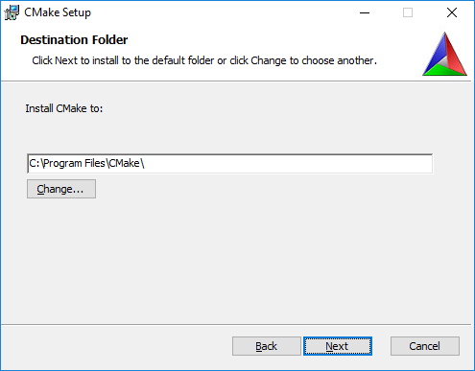

* Keep the default setting then click Next

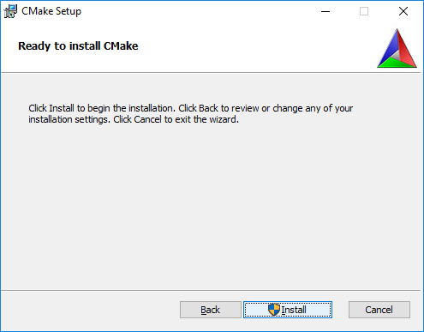

* Click Install to continue

## Install OpenCV and other important packages

* Open command line, then enter following commands:
  + pip install numpy scipy matplotlib scikit-learn jupyter

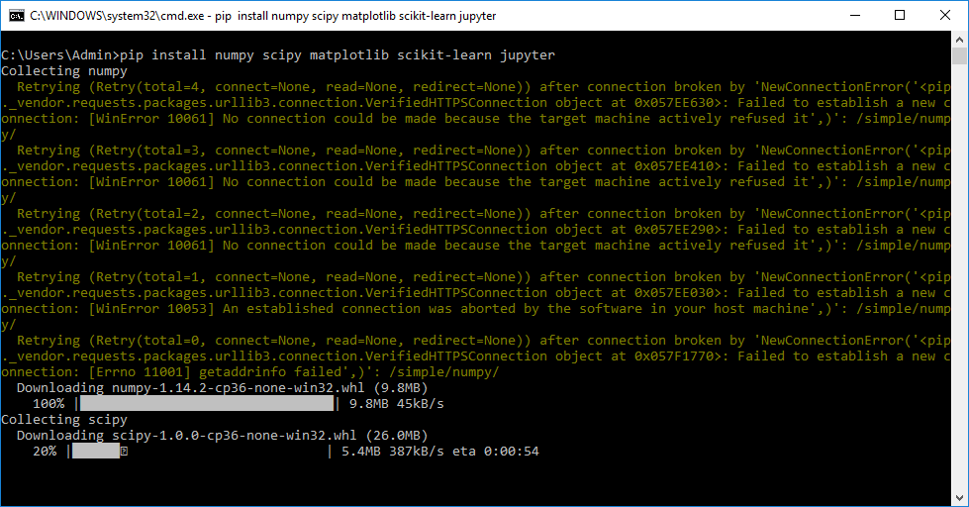

* + pip install opencv-contrib-python

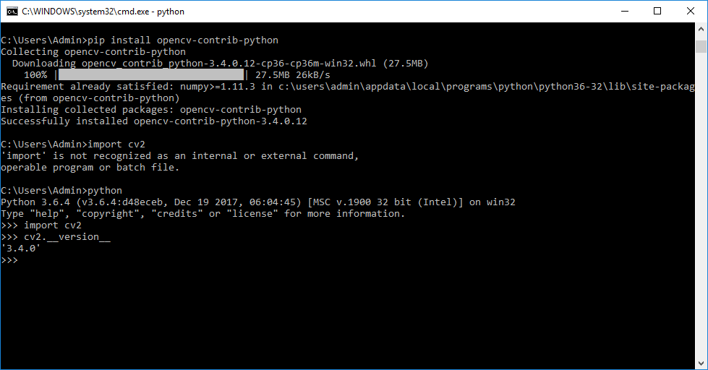

* + pip install dlib

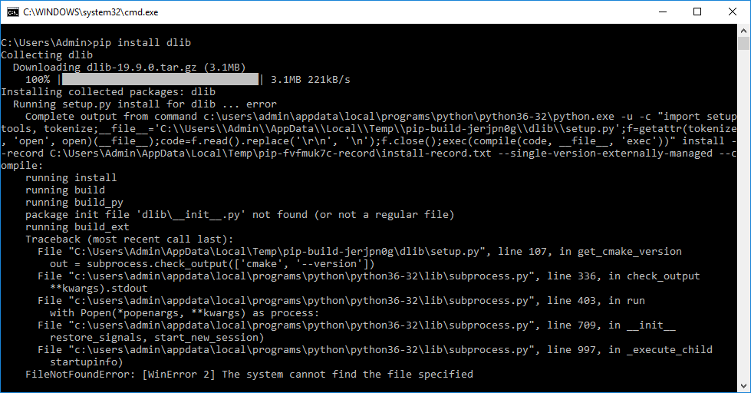

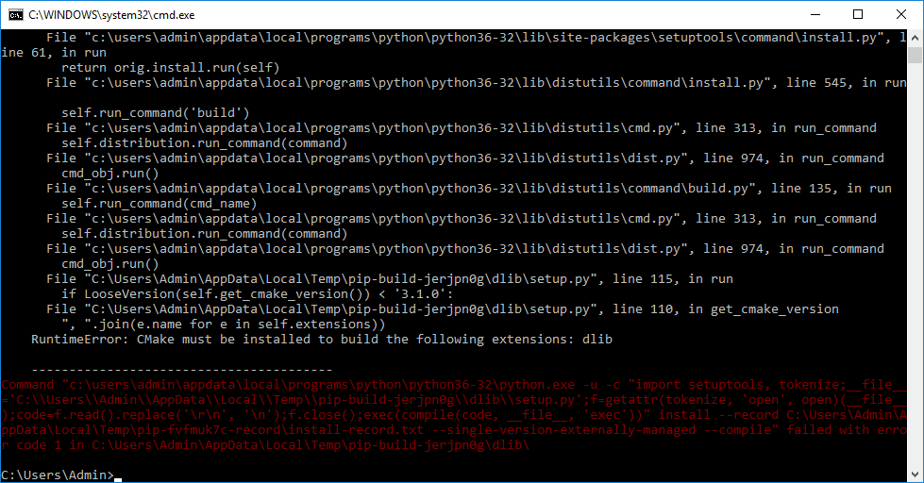

* + Make sure you have already installed cmake before run this command.

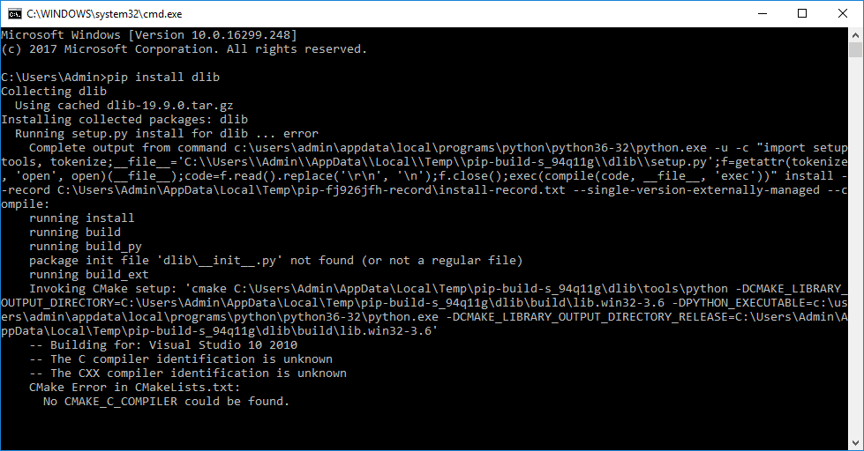

* + Make sure you have already installed Microsoft Build Tools 2015